**Increment 6**

**Budget Tracker**

**User Documentation**

**By Malik Johnson**

**Fall 2019**

Table of Contents

1. Revisions Page
2. Purpose of Budget Tracker
3. Create User.
4. Delete User.
5. Add Item.
6. Add Budget.
7. Modify User
8. Delete Budget
9. Modify Budget
10. Delete Item
11. Modify Item
12. Create Display
13. Display Budget
14. Display Items
15. Display Users
16. Delete Display
17. Display Displays
18. Create Reminder
19. Delete Reminder
20. Display Reminders
21. Display Budget Names
22. Help Info.
23. User table
24. Item table
25. Budget table
26. Display table
27. Reminder table

**Increment 6 Revisions Page**

Pages Added

Delete Display – Page 19

Display Displays – Page 20

Create Reminder – Page 21

Delete Reminder – Page 22

Display Reminders – Page 23

Display Budget Names – Page 24

Help Info – Page 25

Reminder Table – Page 30

Pages Deleted

None

Pages Changed

Purpose of BudgetTracker- Page 4 -updated UI to final Ui.

**Purpose of Budget Tracker**

Budget Tracker Allows you to track a budget through simple means. By creating a user you can create budgets for that user. You can also create items to add to that budget. This leads to the goal of displaying and maintain the budget in an easy manor.

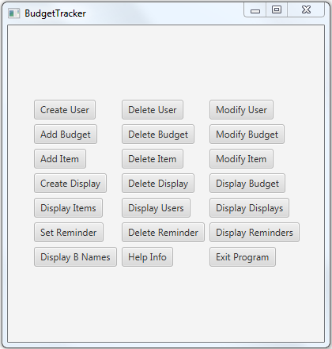

This is the user interface of Budget Tracker. Every button is now functional. When you click on a button a new window is opening for input. The functions of each of the functional buttons will be covered below.

**Create User**

This is the user interface for the create user button.

You can create a username, password, first name, last name, budget amount, income amount, savings amount, number of bank accounts, and bank account total.

The submit button sends the data to the database for storage and clears the fields if there are no exceptions. The clear button clears all fields for easy clearing. The back button closes the window.

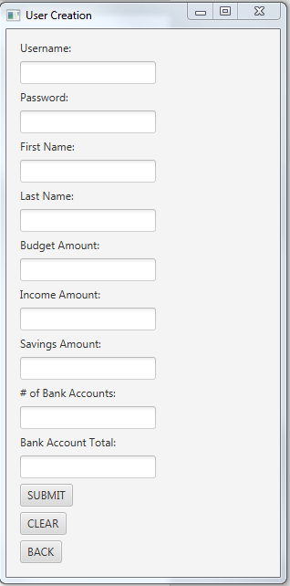

**Delete User**

This is the user interface for the delete user button.

This only requires the username and password of a user for deletion. This is done to make the process as simple as possible.

The delete user button deletes a user if the username and password are in the database.

The back button closes the window.

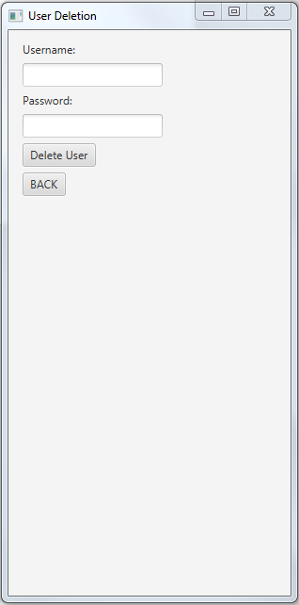

**Add Budget**

This is the user interface for the add budget button.

Here you can select one of the weekly, monthly, yearly options for budgets.

After that you can enter your budget name for your budget.

And then you can enter the username the budget belongs to.

The submit button sends the data to the database and clears all fields. The clear button clears all fields for easy clears. And the back button closes the window.

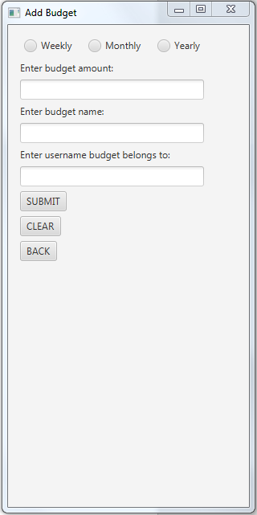

**Add Item**

This is the user interface for the add item button. This is to add an item to a budget that belongs to a user.

You can add item name, price, quantity, purchase date, the budget the item belongs to, and category.

Submit adds the item to the database. Clear clears the fields. And back closes the window.

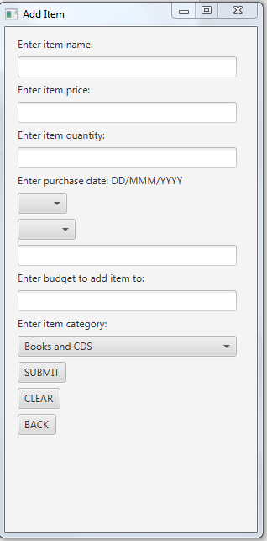

**Modify User**

This is the user interface for the modify user button. This is to modify the information of a user.

You can change username, password, first name, last name, budget amount, income, amount, savings amount, number of bank accounts, and bank account total.

Submit modifies the user. Clear clears the fields, and back closes the window

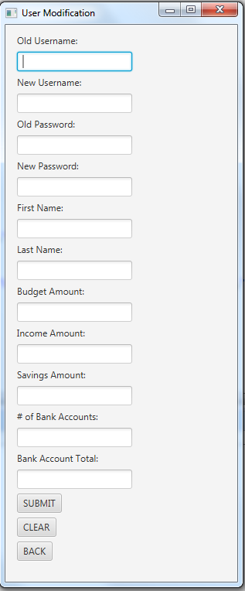

**Delete Budget**

This is the user interface for the delete budget button.

You just need to enter the budget name and the username it belongs to for deletion.

The back button closes the window.

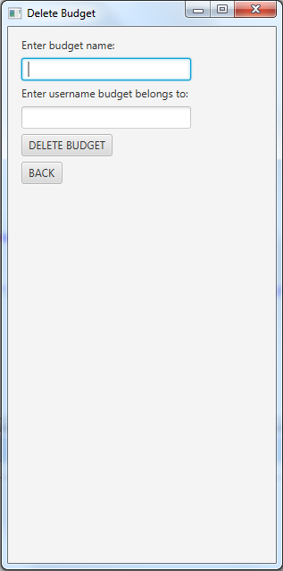

**Modify Budget**

This is the user interface for the modify budget button.

You can change budget type, budget amount, and budget name.

The submit button modifies the budget. The clear button clears the fields, and the back button closes the window

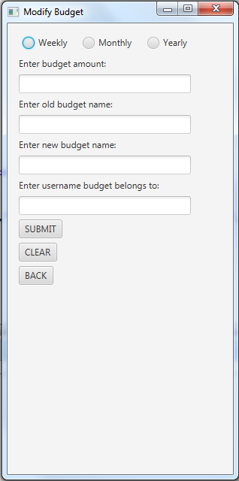

**Delete Item**

This is the user interface for the delete item button.

You just need to enter an item name, purchase date, and budget to delete from.

The delete item button deletes the item from the database. The clear button clears the fields. The back button closes the window.

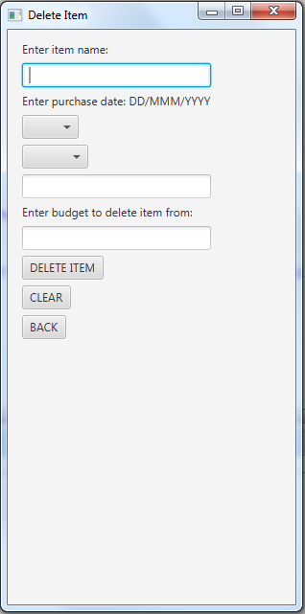

**Modify Item**

This is the user interface for the modify item button.

You can change the item name, price, quantity, purchase date, and category.

Submit modifies the item. The clear button clears the fields. The back button closes the window.

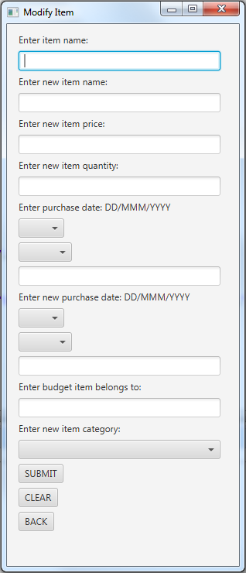

**Create Display**

This is the user interface for the create display button. This creates a budget display.

You can enter a display name, a budget name to tie it to, a graph type option, and an orientation option. The orientation option only affects the bar graph option.

Submit creates the display. Back closes the window.

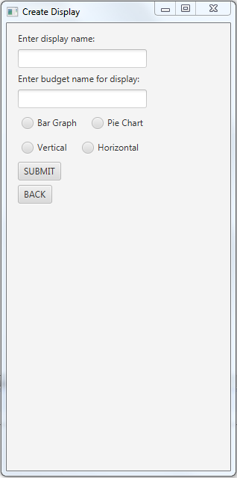

**Display Budget**

This is the user interface for the display budget button.

There are two parts to this UI button.

You enter a display name. Click the submit button. And a budget is displayed.

A bar graph or pie chart is displayed depending on the display you created.

The goal refers to the budget cap you set. Currently refers to the current budget total. Overbudget displays false if the budget is not overbudget and true if it is overbudget.

Spend refers to the amount you should spend based on the weekly/monthly/yearly option selected. Weekly is based on amount/7. Monthly amount/31. Yearly amount/365.

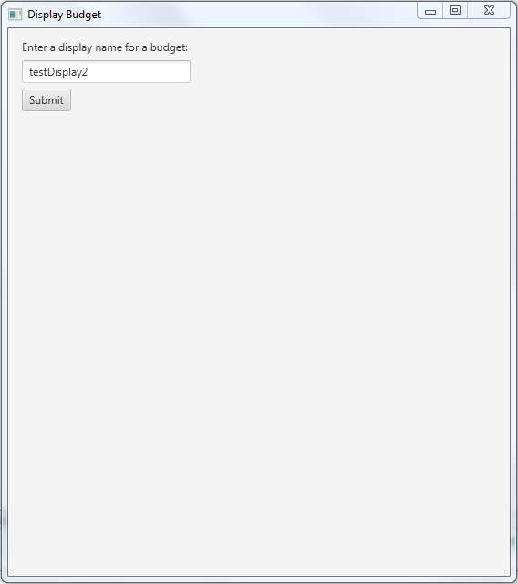

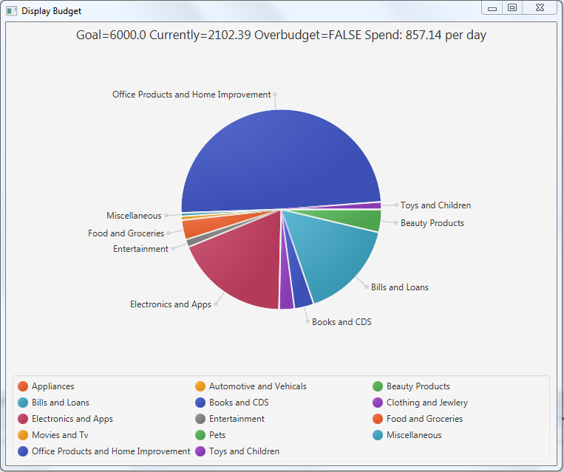

**Display Items**

This is the user interface for the display items button.

When you enter a budget name and click submit. It displays all of the items attached to that budget. It also displays price, quantity, category, and purchase date for the item.

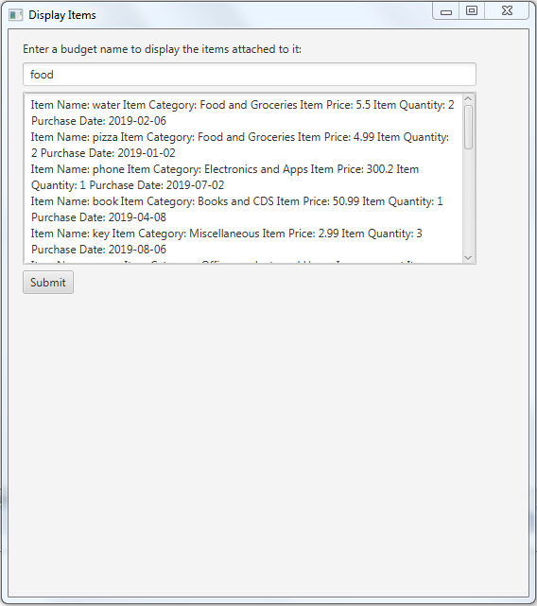

**Display Users**

This is the user interface for the display users button.

There is no user input for this button. It simply displays the users on the system. It is useful incase a username is forgotten.

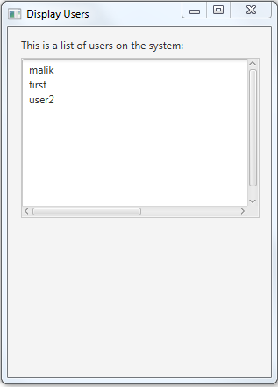

**Delete Displays**

This is the user interface for the delete displays button.

There are two text fields. The name of the display for deletion. And the name of the budget the display belongs to. The submit button deletes the display from the database.

.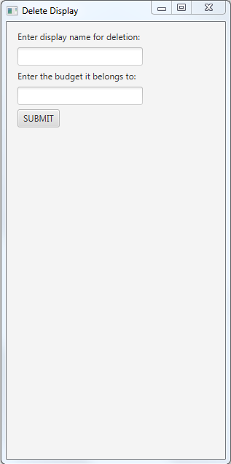

**Display Displays**

This is the user interface for the display displays button.

There is no user input for this button. It simply displays the display names on the system.

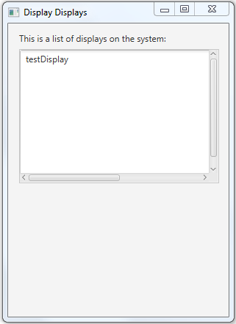

**Create Reminder**

This is the user interface for the create reminder button.

You can enter a reminder name. Set the reminder percent. Set the type of reminder. And specify which budget the reminder will belong to.

Submit will create the reminder. Clear clears the fields. And the back button closes the window.

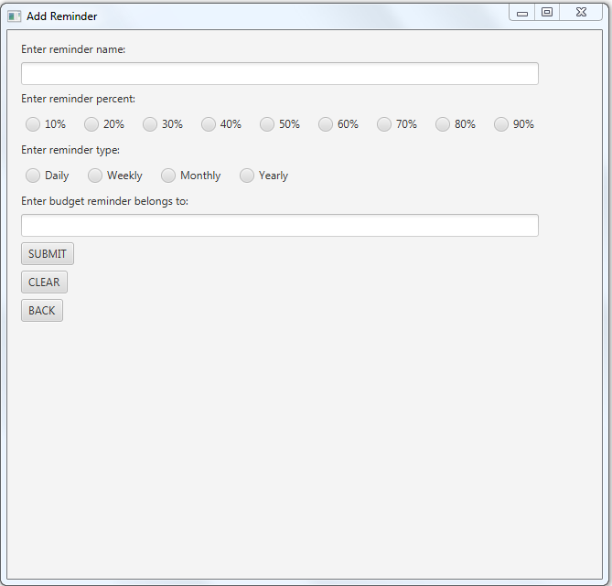

**Delete Reminder**

This is the user interface for the delete reminder button.

Enter a reminder name for deletion. And then enter the budget the reminder belongs to.

Submit will delete the reminder from the database.

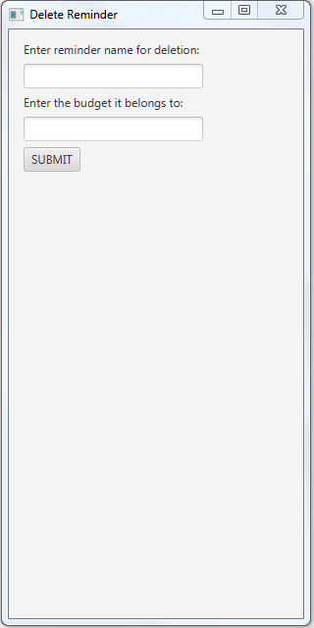

**Display Reminders**

This is the user interface for the display reminders button.

It simply displays the reminder names on the system.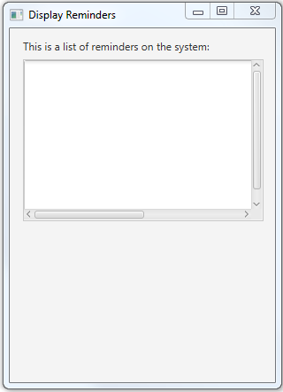

**Display Budget Names**

This is the user interface for the display budget names button.

It simply displays the budget names on the system.

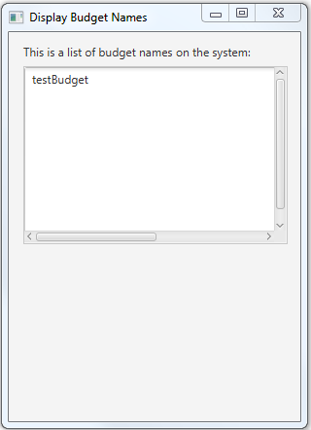

**Help Info**

This is the user interface for the help info button

If provides helpful tips about how to use budget tracker. Click a tab changes the information displayed.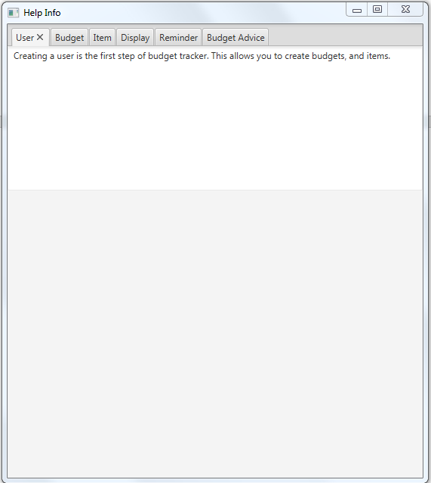

**User Table**

**Describes all fields for the Mj_user table**

|  |  |
| --- | --- |
| Field | Description |
| userId | A unique id for each user. Doesn’t require the user to enter input. |
| userName | The username that defines a user. |
| Password | A password that relates to the username. |
| FirstName | The first name of the user. |
| LastName | The last name of the user. |
| budgetAmount | The amount you want to budget. The budgets you create will check that they don’t go over this amount when added. Must be a number. |
| incomeAmount | The amount of income the user makes. This is used for calculations. Must be a number |
| savingsAmount | The amount of savings the user has in a savings account. This is used for calculations. Must be a number |
| numberOfBankAccounts | The number of bank accounts the user has. Must be a number |
| bankAccountTotal | The total amount in all bank accounts of a user. Must be a number |

**Budget Table**

**Describes all fields for the Mj_budget table**

|  |  |
| --- | --- |
| Field | Description |
| budgetId | A unique id for each budget. Entered automatically |
| budgetType | Three options between monthly, weekly, yearly. Represents the types of budgets you can make. |
| budgetName | The name of the budget. |
| userId | The user id from the Mj_user table. Relates the two tables. Entered by using username of the person the budget belongs to. |
| budgetAmount | The amount to budget. |
| budgetTotal | The budget total that is checked against budget amount when an item is added. |
| overBudget | A true, false for if the budget is overbudget or underbudget. Used to check if adding an item to a budget is okay. Default false. |

**Item table**

**Describes all fields for the Mj_item table**

|  |  |
| --- | --- |
| Field | Description |
| itemId | A unique id for each item. Entered automatically. |
| itemName | The name of the item to be added. |
| itemType | The type of item to be added the drop down menu contains all categories. |
| itemPrice | The price of the item to be added. Cannot be negative |
| itemQuantity | The quantity of the item you want to add. For example two candy bars. Cannot be negative. |
| purchaseDate | The purchase date of the item to be added. Cannot be negative |
| budgetId | BudgetId from the Mj_budget table. Relates the two tables. This is entered by using the budget name the item belongs to. |

**Display Table**

**Describes all fields for the Mj_display table**

|  |  |
| --- | --- |
| Field | Description |
| displayId | A unique id for each display, Entered automatically. |
| displayName | The name of the display. |
| budgetId | BudgetId from the Mj_budget table. Relates the two tables. This is entered by using the budget name the display belongs to. |
| displayLayout | The type of graph or chart that will be displayed. There are two options. A bar graph option and a pie chart option. |
| graphType | This determines the orientation of the graph. The options are vertical and horizontal. This only affects a bar graph and not a pie chart. |

**Reminder Table**

**Describes all fields for the MJ_REMINDER table**

|  |  |
| --- | --- |
| Field | Description |
| reminderId | A unique if for each reminder. Entered automatically. |
| reminderName | The name of the reminder |
| reminderType | The type of reminder. Has four options. Daily, weekly, monthly, and yearly. |
| dateActivated | The date the reminder is activated. Correlates to the reminder types of weekly, monthly, yearly. When first activated it is set to the current date. |
| budgetId | BudgetId from the Mj_budget table. Relates the two tables. This is entered by using the budget name the reminder belongs to. |
| reminderPercent | The percent of the budget amount that when passed will trigger a warning. |